**DELHI TECHNOLOGICAL UNIVERSITY**

**CS305 –: Information Network & Security   
Lab File**

**Submitted by:**  **Submitted to:**

YUG BATHLA   
23/CS/479

CSE1 (A1) ( G3 )

**INDEX**

|  |  |  |
| --- | --- | --- |
| **S.NO** | **EXPERIMENT** | **DATE** |
| 1 | To implement Caesar cipher encryption  Encryption: Replace each plaintext letter with one a Fixed number of  places down the alphabet.  Decryption: Replace each cipher text letter with one a fixed number of  places up the alphabet. | 7/8/25 |
| 2 | To implement Monoalphabetic decryption. Encrypting and Decrypting  works exactly the same for all monoalphabetic ciphers.  Encryption/Decryption: Every letter in the alphabet is represented by  exactly one other letter in the key. | 14/8/25 |
| 3 | To implement Play fair cipher encryption-decryption. | 21/8/25 |
| 4 | To implement Polyalphabetic cipher encryption decryption.  Encryption/Decryption: Based on substitution, using multiple substitution  Alphabets | 28/8/25 |
| 5 | To implement Hill- cipher encryption decryption | 4/9/25 |
| 6 | To implement S-DES sub key Generation | 11/9/25 |
| 7 | To implement Diffie-Hallman key exchange algorithm | 9/10/25 |
| 8 | To implement RSA encryption-decryption. |  |
| 9 | Write a program to generate SHA-1 hash. |  |
| 10 | Implement a digital signature algorithm |  |

EXPERIMENT – 1

**Aim:** To implement Caesar cipher encryption.

Encryption: Replace each plaintext letter with one a Fixed number of

places down the alphabet.

Decryption: Replace each cipher text letter with one a fixed number of

places up the alphabet.

**Theory:**

The **Caesar cipher** is one of the simplest and oldest **encryption techniques**, named after Julius Caesar, who used it in his private correspondence. It is a **substitution cipher** in which each letter in the plaintext is shifted a fixed number of positions down or up the alphabet.

1. **Encryption:**
   * Each letter of the plaintext is replaced by a letter located **a fixed number of positions down the alphabet**.
   * The fixed number is called the **key** or **shift**.
   * For example, with a shift of 3:
   * Plaintext: A B C D E ...
   * Ciphertext: D E F G H ...

**Encryption Formula:**

C = (P + K) mod 26

* + C = Ciphertext letter (numeric value 0–25)
  + P = Plaintext letter (numeric value 0–25)
  + K = Key (shift value)

1. **Decryption:**
   * To retrieve the original text, each letter in the ciphertext is shifted **up by the same key value**.
   * **Decryption Formula:** P = (C - K + 26) mod 26
   * P = Original plaintext letter
   * C = Ciphertext letter
   * K = Key (shift value)

**Characteristics**

* **Symmetric Cipher:**  
  The same key is used for encryption and decryption.
* **Alphabetic Substitution:**  
  Only letters are substituted; spaces and punctuation may remain unchanged.
* **Fixed Shift:**  
  All letters are shifted by the same amount.

**Source code:**

#include <iostream>

#include <string>

using namespace std;

// Encrypt a message using Caesar Cipher

string encrypt(string text, int shift) {

string result = "";

for (char c : text) {

if (isupper(c)) {

result += char((c - 'A' + shift) % 26 + 'A');

} else if (islower(c)) {

result += char((c - 'a' + shift) % 26 + 'a');

} else {

result += c; // leave non-alphabet characters unchanged

}

}

return result;

}

// Decrypt a message using Caesar Cipher

string decrypt(string text, int shift) {

string result = "";

for (char c : text) {

if (isupper(c)) {

result += char((c - 'A' - shift + 26) % 26 + 'A');

} else if (islower(c)) {

result += char((c - 'a' - shift + 26) % 26 + 'a');

} else {

result += c;

}

}

return result;

}

int main() {

string text;

int shift, choice;

cout << "Caesar Cipher\n";

cout << "1. Encrypt\n2. Decrypt\nChoose (1 or 2): ";

cin >> choice;

cin.ignore(); // ignore newline character left in input buffer

cout << "Enter text: ";

getline(cin, text);

cout << "Enter shift value (e.g., 3): ";

cin >> shift;

if (choice == 1) {

cout << "Encrypted Text: " << encrypt(text, shift) << endl;

} else if (choice == 2) {

cout << "Decrypted Text: " << decrypt(text, shift) << endl;

} else {

cout << "Invalid choice.\n";

}

return 0;

}

**Output:**

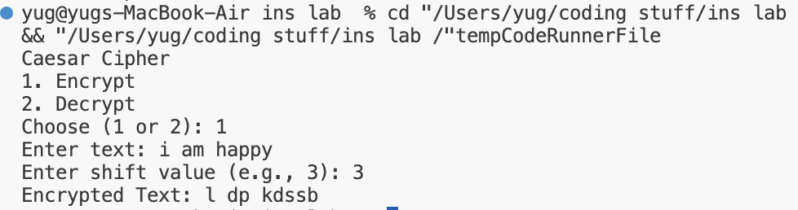

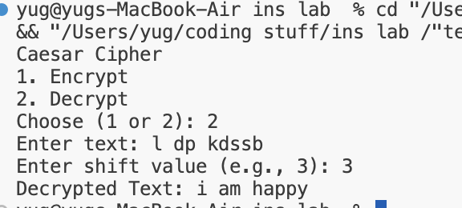

EXPERIMENT – 2

**Aim:** To implement Monoalphabetic decryption. Encrypting and Decrypting

works exactly the same for all monoalphabetic ciphers.

Encryption/Decryption: Every letter in the alphabet is represented by

exactly one other letter in the key.

**Theory:**

A **Monoalphabetic Cipher** is a **substitution cipher** in which each letter of the plaintext is replaced by exactly **one unique letter** of the alphabet according to a **fixed key**. Unlike Caesar cipher, the shift doesn’t have to be uniform; any mapping between plaintext and ciphertext letters is allowed.

**Working Principle**

1. **Encryption:**
   * Each plaintext letter is replaced by its corresponding letter in the key.
   * Example Key Mapping:
   * Plain: A B C D E F G H I J ...
   * Cipher: Q W E R T Y U I O P ...
   * Plaintext “HELLO” → Ciphertext “ITSSG”
2. **Decryption:**
   * To decrypt, each ciphertext letter is replaced with its corresponding plaintext letter using the **reverse mapping**.

**Characteristics**

* **Fixed substitution:** Each letter has exactly **one corresponding ciphertext letter**.
* **Symmetric key:** Same key is required for encryption and decryption.
* **Alphabet-only substitution:** Typically, only letters are encrypted; numbers and punctuation remain unchanged.

**Advantages**

* Simple to implement and understand.
* Offers more variability than Caesar cipher.

**Limitations**

* Vulnerable to **frequency analysis**, as the mapping is static.
* Less secure for large texts without additional techniques.

**Applications**

* Used historically for confidential messages.
* Educational purposes for learning basic cryptography.

**Source code:**

#include <iostream>

#include <string>

#include <unordered_map>

using namespace std;

// Function to build mapping from standard to key alphabet

unordered_map<char, char> buildMap(const string& from, const string& to) {

unordered_map<char, char> map;

for (int i = 0; i < 26; ++i) {

map[from[i]] = to[i];

}

return map;

}

// Function to encrypt or decrypt text

string monoalphabeticCipher(const string& text, const unordered_map<char, char>& map) {

string result = "";

for (char c : text) {

if (isupper(c)) {

result += toupper(map.at(tolower(c)));

} else if (islower(c)) {

result += map.at(c);

} else {

result += c; // Keep non-alphabetic characters unchanged

}

}

return result;

}

int main() {

string plainAlphabet = "abcdefghijklmnopqrstuvwxyz";

// Monoalphabetic key (must be a permutation of 26 unique letters)

string keyAlphabet = "qwertyuiopasdfghjklzxcvbnm"; // key

// Build encrypt and decrypt maps

unordered_map<char, char> encryptMap = buildMap(plainAlphabet, keyAlphabet);

unordered_map<char, char> decryptMap = buildMap(keyAlphabet, plainAlphabet);

int choice;

string input;

cout << "Monoalphabetic Cipher\n";

cout << "1. Encrypt\n2. Decrypt\nChoose (1 or 2): ";

cin >> choice;

cin.ignore(); // flush newline

cout << "Enter text: ";

getline(cin, input);

if (choice == 1) {

cout << "Encrypted Text: " << monoalphabeticCipher(input, encryptMap) << endl;

} else if (choice == 2) {

cout << "Decrypted Text: " << monoalphabeticCipher(input, decryptMap) << endl;

} else {

cout << "Invalid choice." << endl;

}

return 0;

}

**Output:**

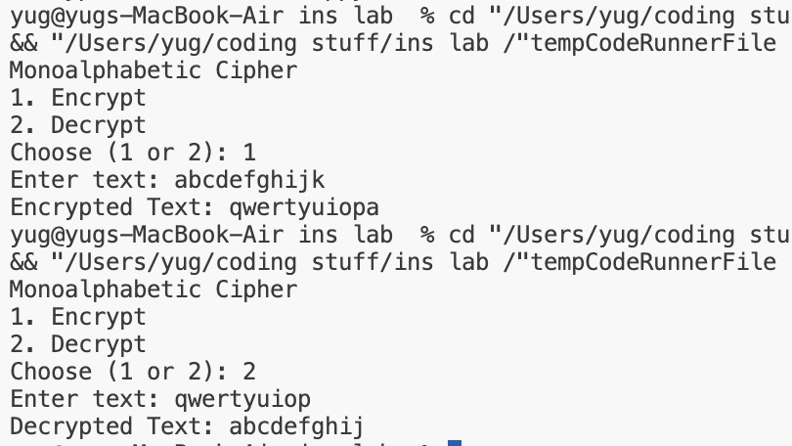

EXPERIMENT – 3

**Aim:** To implement Play fair cipher encryption-decryption.

**Theory:**

The **Playfair Cipher** is a **digraph substitution cipher** invented by Charles Wheatstone (and promoted by Lord Playfair) in 1854.

* Instead of encrypting single letters, **two letters at a time (digraphs)** are encrypted, making it more secure than monoalphabetic ciphers.

**Working Principle**

1. **Key Table Creation**
   * A **5×5 matrix** is filled with letters of a key (replacing J with I), followed by the remaining letters of the alphabet in order.
   * Example:
   * K E Y W O
   * R D A B C
   * F G H I L
   * M N P Q S
   * T U V X Z
2. **Encryption Rules**
   * Break plaintext into digraphs (pairs of letters). If a digraph has identical letters, insert a filler (like X).
   * For each digraph:
     1. **Same row:** Replace each letter with the letter to its **right** (wrap around at end).
     2. **Same column:** Replace each letter with the letter **below** (wrap around at bottom).
     3. **Rectangle:** Replace each letter with the letter in the **same row but the column of the other letter**.
3. **Decryption Rules**
   * Reverse the encryption rules:
     1. **Same row:** Letter to **left**.
     2. **Same column:** Letter **above**.
     3. **Rectangle:** Swap columns as in encryption.

**Characteristics**

* Encrypts **pairs of letters (digraphs)** instead of single letters.
* Provides better **security** than monoalphabetic cipher.
* Uses a **5×5 key table**, combining I/J into a single letter.

**Advantages**

* Harder to break using simple frequency analysis.
* Encrypts more than one letter at a time, improving security.

**Limitations**

* Slightly complex compared to monoalphabetic cipher.
* Still vulnerable to **modern cryptanalysis**.

**Applications**

* Historically used for military communication.
* Good for **educational purposes** to demonstrate digraph encryption.

**Source code:**

#include <iostream>

#include <vector>

#include <string>

#include <map>

#include <cctype>

using namespace std;

class PlayfairCipher {

vector<vector<char>> keyTable;

map<char, pair<int, int>> pos; // letter -> (row, col)

public:

PlayfairCipher(string key) {

createKeyTable(key);

}

void createKeyTable(string key) {

vector<bool> used(26, false);

keyTable.assign(5, vector<char>(5, ' '));

string filteredKey;

// Uppercase, replace J with I, remove duplicates

for (char c : key) {

c = toupper(static_cast<unsigned char>(c));

if (c == 'J') c = 'I';

if (c < 'A' || c > 'Z') continue;

if (!used[c - 'A']) {

used[c - 'A'] = true;

filteredKey.push_back(c);

}

}

// Add remaining letters

for (char c = 'A'; c <= 'Z'; c++) {

if (c == 'J') continue;

if (!used[c - 'A']) {

used[c - 'A'] = true;

filteredKey.push_back(c);

}

}

// Fill 5x5 table

int idx = 0;

for (int i = 0; i < 5; i++) {

for (int j = 0; j < 5; j++) {

keyTable[i][j] = filteredKey[idx];

pos[filteredKey[idx]] = {i, j};

idx++;

}

}

}

string prepareText(string text, bool forEncryption) {

string processed;

for (char c : text) {

c = toupper(static_cast<unsigned char>(c));

if (c == 'J') c = 'I';

if (c >= 'A' && c <= 'Z') processed.push_back(c);

}

if (forEncryption) {

string result;

for (size_t i = 0; i < processed.size(); i++) {

result.push_back(processed[i]);

if (i + 1 == processed.size()) {

result.push_back('X'); // padding

} else if (processed[i] == processed[i + 1]) {

result.push_back('X');

} else {

result.push_back(processed[i + 1]);

i++;

}

}

return result;

}

return processed; // For decryption, no digraph processing needed

}

string encrypt(string plaintext) {

string text = prepareText(plaintext, true);

string cipher;

for (size_t i = 0; i < text.size(); i += 2) {

char a = text[i], b = text[i + 1];

pair<int, int> p1 = pos[a];

pair<int, int> p2 = pos[b];

int r1 = p1.first, c1 = p1.second;

int r2 = p2.first, c2 = p2.second;

if (r1 == r2) { // Same row

cipher.push_back(keyTable[r1][(c1 + 1) % 5]);

cipher.push_back(keyTable[r2][(c2 + 1) % 5]);

} else if (c1 == c2) { // Same column

cipher.push_back(keyTable[(r1 + 1) % 5][c1]);

cipher.push_back(keyTable[(r2 + 1) % 5][c2]);

} else { // Rectangle

cipher.push_back(keyTable[r1][c2]);

cipher.push_back(keyTable[r2][c1]);

}

}

return cipher;

}

string decrypt(string ciphertext) {

string text = prepareText(ciphertext, false);

string plain;

for (size_t i = 0; i < text.size(); i += 2) {

char a = text[i], b = text[i + 1];

auto [r1, c1] = pos[a];

auto [r2, c2] = pos[b];

if (r1 == r2) { // Same row

plain.push_back(keyTable[r1][(c1 + 4) % 5]);

plain.push_back(keyTable[r2][(c2 + 4) % 5]);

} else if (c1 == c2) { // Same column

plain.push_back(keyTable[(r1 + 4) % 5][c1]);

plain.push_back(keyTable[(r2 + 4) % 5][c2]);

} else { // Rectangle

plain.push_back(keyTable[r1][c2]);

plain.push_back(keyTable[r2][c1]);

}

}

return plain;

}

void printKeyTable() {

for (auto &row : keyTable) {

for (char c : row) cout << c << ' ';

cout << "\n";

}

}

};

int main() {

string key, plaintext;

cout << "Enter key: ";

getline(cin, key);

PlayfairCipher cipher(key);

cout << "\nKey Table:\n";

cipher.printKeyTable();

cout << "\nEnter plaintext: ";

getline(cin, plaintext);

string encrypted = cipher.encrypt(plaintext);

string decrypted = cipher.decrypt(encrypted);

cout << "\nPlaintext: " << plaintext;

cout << "\nEncrypted: " << encrypted;

cout << "\nDecrypted: " << decrypted << "\n";

return 0;

}

**Output:**

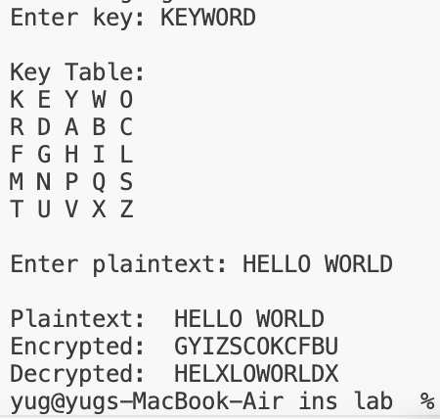

EXPERIMENT – 4

**Aim:** To implement Polyalphabetic cipher encryption decryption.

Encryption/Decryption: Based on substitution, using multiple substitution

Alphabets

**Theory:**

A **polyalphabetic cipher** uses **multiple substitution alphabets** to encrypt plaintext, unlike monoalphabetic ciphers which use a single substitution.

* Famous example: **Vigenère cipher**.

**Working Principle**

1. A **key (sequence of letters)** determines which substitution alphabet to use.
2. Each letter of plaintext is encrypted using a **different Caesar shift** according to the key.
3. Encryption formula:
4. C_i = (P_i + K_i) mod 26
   * C_i = Ciphertext letter
   * P_i = Plaintext letter
   * K_i = Key letter corresponding to that position
5. Decryption formula:
6. P_i = (C_i - K_i + 26) mod 26

**Characteristics**

* Uses **multiple Caesar shifts**, making frequency analysis harder.
* Symmetric key cipher.
* Plaintext letters are **spread over multiple alphabets**.

**Advantages**

* More secure than monoalphabetic substitution.
* Reduces predictability of letter frequencies.

**Applications**

* Vigenère cipher for secure communication.
* Educational demonstration of **polyalphabetic substitution**.

**Source code:**

#include <iostream>

#include <string>

using namespace std;

// Function to generate repeating key (ignores non-alphabet characters)

string generateKey(const string &text, const string &key) {

string newKey;

int j = 0; // index for key

for (size_t i = 0; i < text.size(); i++) {

if (isalpha(text[i])) {

newKey.push_back(key[j % key.size()]);

j++;

} else {

newKey.push_back(text[i]); // keep spaces/punctuation aligned

}

}

return newKey;

}

// Encrypt function

string encryptText(const string &text, const string &key) {

string cipher_text;

for (size_t i = 0; i < text.size(); i++) {

if (isupper(text[i])) {

char x = ((text[i] - 'A') + (toupper(key[i]) - 'A')) % 26 + 'A';

cipher_text.push_back(x);

} else if (islower(text[i])) {

char x = ((text[i] - 'a') + (tolower(key[i]) - 'a')) % 26 + 'a';

cipher_text.push_back(x);

} else {

cipher_text.push_back(text[i]); // leave spaces/punctuation

}

}

return cipher_text;

}

// Decrypt function

string decryptText(const string &cipher_text, const string &key) {

string orig_text;

for (size_t i = 0; i < cipher_text.size(); i++) {

if (isupper(cipher_text[i])) {

char x = ((cipher_text[i] - 'A') - (toupper(key[i]) - 'A') + 26) % 26 + 'A';

orig_text.push_back(x);

} else if (islower(cipher_text[i])) {

char x = ((cipher_text[i] - 'a') - (tolower(key[i]) - 'a') + 26) % 26 + 'a';

orig_text.push_back(x);

} else {

orig_text.push_back(cipher_text[i]);

}

}

return orig_text;

}

int main() {

string text, keyword;

cout << "Enter plaintext: ";

getline(cin, text);

cout << "Enter key (letters only): ";

cin >> keyword;

string key = generateKey(text, keyword);

string cipher_text = encryptText(text, key);

cout << "\nEncrypted Text : " << cipher_text << endl;

cout << "Decrypted Text : " << decryptText(cipher_text, key) << endl;

return 0;

}

**Output:**

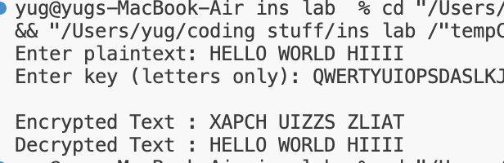

EXPERIMENT – 5

**Aim:** To implement Hill- cipher encryption decryption

**Theory:**

The **Hill cipher** is a **polygraphic substitution cipher** based on **linear algebra**.

* Encrypts plaintext in blocks (vectors) of size **n** using an **n×n key matrix**.
* Developed by Lester Hill in 1929.

**Working Principle**

1. Represent plaintext letters as **numbers (A=0, B=1, … Z=25)**.
2. Divide plaintext into blocks of size **n**.
3. Encryption formula:
4. C = (K * P) mod 26
   * C = Ciphertext vector
   * K = Key matrix (invertible modulo 26)
   * P = Plaintext vector
5. Decryption formula:
6. P = (K^-1 * C) mod 26
   * K^-1 = Modular inverse of key matrix modulo 26

**Characteristics**

* **Polygraphic cipher**: Encrypts multiple letters at once.
* Requires **invertible key matrix**.
* Provides better security than monoalphabetic ciphers.

**Applications**

* Classical cryptography education.
* Demonstrates **linear algebra in encryption**.

**Source code :**

#include <iostream>

#include <vector>

#include <string>

#include <algorithm>

using namespace std;

// Function to get modulo inverse of a number under mod 26

int modInverse(int a, int m) {

a = a % m;

for (int x = 1; x < m; x++) {

if ((a * x) % m == 1) return x;

}

return -1;

}

// Function to get determinant of matrix (only for 2x2 and 3x3)

int determinant(const vector<vector<int>> &mat, int n) {

if (n == 2)

return (mat[0][0]*mat[1][1] - mat[0][1]*mat[1][0]);

else if (n == 3)

return (mat[0][0]*(mat[1][1]*mat[2][2] - mat[1][2]*mat[2][1])

- mat[0][1]*(mat[1][0]*mat[2][2] - mat[1][2]*mat[2][0])

+ mat[0][2]*(mat[1][0]*mat[2][1] - mat[1][1]*mat[2][0]));

return 0;

}

// Function to get adjoint of 2x2 or 3x3 matrix

vector<vector<int>> adjoint(const vector<vector<int>> &mat, int n) {

vector<vector<int>> adj(n, vector<int>(n));

if (n == 2) {

adj[0][0] = mat[1][1];

adj[0][1] = -mat[0][1];

adj[1][0] = -mat[1][0];

adj[1][1] = mat[0][0];

} else if (n == 3) {

for (int i = 0; i < n; i++) {

for (int j = 0; j < n; j++) {

vector<vector<int>> temp(2, vector<int>(2));

int r = 0;

for (int k = 0; k < n; k++) {

if (k == i) continue;

int c = 0;

for (int l = 0; l < n; l++) {

if (l == j) continue;

temp[r][c] = mat[k][l];

c++;

}

r++;

}

adj[j][i] = ((temp[0][0]*temp[1][1] - temp[0][1]*temp[1][0]) * (((i+j)%2==0)?1:-1));

}

}

}

return adj;

}

// Function to get inverse of matrix mod 26

vector<vector<int>> inverseMatrix(const vector<vector<int>> &mat, int n) {

int det = determinant(mat, n);

det = (det % 26 + 26) % 26;

int invDet = modInverse(det, 26);

if (invDet == -1) {

throw runtime_error("Key matrix is not invertible mod 26");

}

vector<vector<int>> adj = adjoint(mat, n);

vector<vector<int>> inv(n, vector<int>(n));

for (int i = 0; i < n; i++) {

for (int j = 0; j < n; j++) {

int val = adj[i][j] * invDet;

val = (val % 26 + 26) % 26;

inv[i][j] = val;

}

}

return inv;

}

// Function to multiply matrix and vector mod 26

vector<int> multiply(const vector<vector<int>> &mat, const vector<int> &vec, int n) {

vector<int> res(n);

for (int i = 0; i < n; i++) {

int sum = 0;

for (int j = 0; j < n; j++) {

sum += mat[i][j] * vec[j];

}

res[i] = (sum % 26 + 26) % 26;

}

return res;

}

string processText(const string &text, int n) {

string t = text;

t.erase(remove_if(t.begin(), t.end(), [](char c){ return !isalpha(c); }), t.end());

transform(t.begin(), t.end(), t.begin(), ::toupper);

while (t.size() % n != 0) t += 'X';

return t;

}

string encrypt(const string &plaintext, const vector<vector<int>> &key, int n) {

string pt = processText(plaintext, n);

string ct;

for (size_t i = 0; i < pt.size(); i += n) {

vector<int> block(n);

for (int j = 0; j < n; j++) block[j] = pt[i+j] - 'A';

vector<int> enc = multiply(key, block, n);

for (int j = 0; j < n; j++) ct += (enc[j] + 'A');

}

return ct;

}

string decrypt(const string &ciphertext, const vector<vector<int>> &key, int n) {

vector<vector<int>> invKey = inverseMatrix(key, n);

string ct = processText(ciphertext, n);

string pt;

for (size_t i = 0; i < ct.size(); i += n) {

vector<int> block(n);

for (int j = 0; j < n; j++) block[j] = ct[i+j] - 'A';

vector<int> dec = multiply(invKey, block, n);

for (int j = 0; j < n; j++) pt += (dec[j] + 'A');

}

return pt;

}

int main() {

int n;

cout << "Enter size of key matrix (2 or 3): ";

cin >> n;

if (n != 2 && n != 3) {

cout << "Only 2x2 or 3x3 matrices supported.\n";

return 1;

}

vector<vector<int>> key(n, vector<int>(n));

cout << "Enter key matrix (row-wise):\n";

for (int i = 0; i < n; i++)

for (int j = 0; j < n; j++)

cin >> key[i][j];

cin.ignore();

string text;

cout << "Enter text: ";

getline(cin, text);

int choice;

cout << "1. Encrypt\n2. Decrypt\nEnter choice: ";

cin >> choice;

try {

if (choice == 1) {

string ct = encrypt(text, key, n);

cout << "Encrypted text: " << ct << endl;

} else if (choice == 2) {

string pt = decrypt(text, key, n);

cout << "Decrypted text: " << pt << endl;

} else {

cout << "Invalid choice.\n";

}

} catch (const exception &e) {

cout << "Error: " << e.what() << endl;

}

return 0;

}

**Output:**

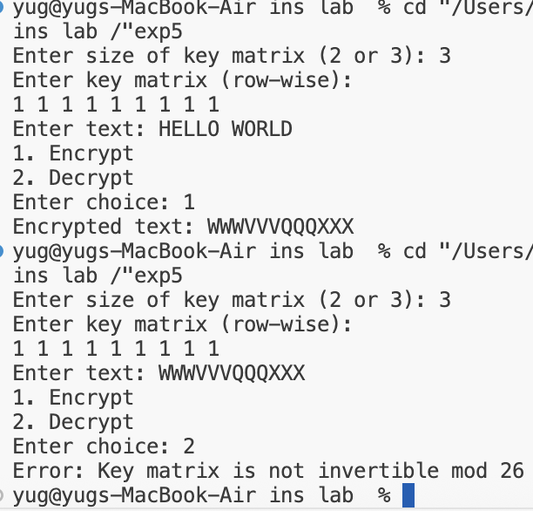

EXPERIMENT – 6

**Aim:** To implement S-DES sub key Generation

**Theory:**

Simplified Data Encryption Standard (**S-DES**) is a simplified version of the DES encryption algorithm designed for **educational purposes**.

* S-DES operates on **8-bit plaintext** using a **10-bit key**.
* It uses **two 8-bit subkeys (K1 and K2)** generated from the original key.

**Key Generation Process**

1. **Input 10-bit key**.
2. **Permutation P10**: Rearrange the 10 bits according to a fixed permutation.
3. **Split into two halves**: Left (L) and Right (R), each 5 bits.
4. **Left shift (LS-1)**: Circular left shift on each half.
5. **Permutation P8**: Select 8 bits from the shifted halves to form **K1**.
6. **Left shift (LS-2)**: Circular left shift by 2 bits on each half.
7. **Permutation P8**: Form **K2**.

**Characteristics**

* Generates **two subkeys** for the encryption rounds.
* Used in the S-DES **Feistel structure** for encryption/decryption.

**Applications**

* Educational purposes to demonstrate **key scheduling** and Feistel encryption.

**Source code:**

#include <iostream>

#include <string>

#include <vector>

using namespace std;

// Function to permute the key based on the given permutation table

string permute(const string& key, const vector<int>& table) {

string permutedKey;

for (int i : table) {

permutedKey += key[i - 1]; // -1 for zero-based indexing

}

return permutedKey;

}

// Function to perform left shift on the given bits

string leftShift(const string& bits) {

return bits.substr(1) + bits[0]; // Shift left

}

// Function to generate subkeys K1 and K2 from the given key

void generateSubkeys(const string& key, string& K1, string& K2) {

// P10 and P8 permutation tables

vector<int> P10 = {3, 5, 2, 7, 4, 10, 1, 9, 8, 6};

vector<int> P8 = {6, 3, 7, 4, 8, 5, 10, 9};

// Step 1: Permute the key using P10

string permutedKey = permute(key, P10);

// Step 2: Split the key into two halves

string leftHalf = permutedKey.substr(0, 5);

string rightHalf = permutedKey.substr(5, 5);

// Step 3: Generate K1

leftHalf = leftShift(leftHalf);

rightHalf = leftShift(rightHalf);

K1 = permute(leftHalf + rightHalf, P8);

// Step 4: Generate K2

leftHalf = leftShift(leftHalf);

rightHalf = leftShift(rightHalf);

K2 = permute(leftHalf + rightHalf, P8);

}

int main() {

string key;

// Input 10-bit binary key

cout << "Enter a 10-bit binary key: ";

cin >> key;

// Validate key length

if (key.length() != 10) {

cout << "Error: Key must be exactly 10 bits long." << endl;

return 1;

}

// Variables to hold the subkeys

string K1, K2;

// Generate subkeys

generateSubkeys(key, K1, K2);

// Output the subkeys

cout << "Subkey K1: " << K1 << endl;

cout << "Subkey K2: " << K2 << endl;

return 0;

}

**Output:**

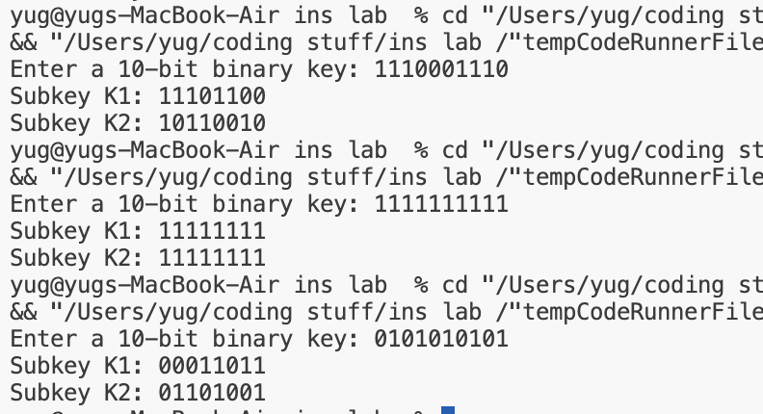

EXPERIMENT – 7

**Aim:** Write a program to implement Diffie-Hallman key exchange algorithm

**Theory:**

The **Diffie–Hellman Key Exchange (DHKE)** algorithm allows two parties — traditionally called **Alice** and **Bob** — to **securely establish a shared secret key** over an insecure communication channel.

This shared key can later be used to **encrypt** and **decrypt** messages (for example, in symmetric encryption like AES).

DHKE relies on the **difficulty of the discrete logarithm problem** — that is, given  
, it is computationally infeasible to find if is large enough.

#### **Steps:**

1. Both users agree on a **prime number (p)** and a **primitive root (g)** publicly.
2. Alice selects a private key **a**, and Bob selects **b**.
3. Alice computes **A = g^a mod p**, Bob computes **B = g^b mod p**, and they exchange A and B.
4. Alice computes **S = B^a mod p**, Bob computes **S = A^b mod p**.
5. Both get the **same shared secret key (S)**.

**Source code:**

#include <cmath>

#include <iostream>

using namespace std;

// Power function to return value of a ^ b mod P

long long int power(long long int a, long long int b,

long long int P)

{

if (b == 1)

return a;

else

return (((long long int)pow(a, b)) % P);

}

// Driver program

int main()

{

long long int P, G, x, a, y, b, ka, kb;

// Both the persons will be agreed upon the

// public keys G and P

P = 23; // A prime number P is taken

cout << "The value of P : " << P << endl;

G = 9; // A primitive root for P, G is taken

cout << "The value of G : " << G << endl;

// Alice will choose the private key a

a = 4; // a is the chosen private key

cout << "The private key a for Alice : " << a << endl;

x = power(G, a, P); // gets the generated key

// Bob will choose the private key b

b = 3; // b is the chosen private key

cout << "The private key b for Bob : " << b << endl;

y = power(G, b, P); // gets the generated key

// Generating the secret key after the exchange

// of keys

ka = power(y, a, P); // Secret key for Alice

kb = power(x, b, P); // Secret key for Bob

cout << "Secret key for the Alice is : " << ka << endl;

cout << "Secret key for the Bob is : " << kb << endl;

return 0;

}

**Output:**

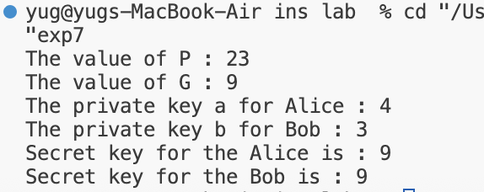

EXPERIMENT – 8

**Aim:** Write a program to implement RSA encryption-decryption.

**Theory:**

The **RSA algorithm** is an **asymmetric cryptographic technique** used for **secure data transmission**.  
It uses **two keys** — a **public key** for encryption and a **private key** for decryption.

**Steps:**

1. **Key Generation:**
   * Choose two large prime numbers **p** and **q**.
   * Compute **n = p × q**.
   * Compute **φ(n) = (p − 1)(q − 1)**.
   * Choose an integer **e** such that 1 < e < φ(n) and **gcd(e, φ(n)) = 1**.
   * Compute **d**, the modular inverse of **e** (i.e., d × e ≡ 1 mod φ(n)).
   * Public key: **(e, n)**  
     Private key: **(d, n)**
2. **Encryption:**
   * Convert the plaintext message **M** into an integer.
   * Compute ciphertext **C = M^e mod n**.
3. **Decryption:**
   * Compute plaintext **M = C^d mod n** using the private key.

### **Features:**

* Based on the **difficulty of factoring large prime numbers**.
* Provides **confidentiality**, **authentication**, and **digital signatures**.
* Widely used in **secure communication**, **SSL/TLS**, and **digital certificates**.

### **Advantages:**

* High security for key exchange and digital signatures.
* Public key can be shared freely without revealing private key.

### **Limitations:**

* Slower compared to symmetric algorithms like AES.
* Requires large key sizes for modern security.

**Source code:**

#include <iostream>

#include <cmath>

#include <algorithm>

using namespace std;

// Function to compute base^expo mod m

int power(int base, int expo, int m) {

int res = 1;

base = base % m;

while (expo > 0) {

if (expo & 1)

res = (res * 1LL * base) % m;

base = (base * 1LL * base) % m;

expo = expo / 2;

}

return res;

}

// Function to find modular inverse of e modulo phi(n)

// Here we are calculating phi(n) using Hit and Trial Method

// but we can optimize it using Extended Euclidean Algorithm

int modInverse(int e, int phi) {

for (int d = 2; d < phi; d++) {

if ((e * d) % phi == 1)

return d;

}

return -1;

}

// Compute GCD (since __gcd is not standard on all compilers)

int gcdCustom(int a, int b) {

while (b != 0) {

int t = b;

b = a % b;

a = t;

}

return a;

}

// RSA Key Generation

void generateKeys(int &e, int &d, int &n) {

int p = 7919;

int q = 1009;

n = p * q;

int phi = (p - 1) * (q - 1);

// Choose e, where 1 < e < phi(n) and gcd(e, phi(n)) == 1

for (e = 2; e < phi; e++) {

if (gcdCustom(e, phi) == 1)

break;

}

// Compute d such that e * d ≡ 1 (mod phi(n))

d = modInverse(e, phi);

}

// Encrypt message using public key (e, n)

int encrypt(int m, int e, int n) {

return power(m, e, n);

}

// Decrypt message using private key (d, n)

int decrypt(int c, int d, int n) {

return power(c, d, n);

}

int main() {

int e, d, n;

// Key Generation

generateKeys(e, d, n);

cout << "Public Key (e, n): (" << e << ", " << n << ")\n";

cout << "Private Key (d, n): (" << d << ", " << n << ")\n";

// Message

int M = 123;

cout << "Original Message: " << M << endl;

// Encrypt the message

int C = encrypt(M, e, n);

cout << "Encrypted Message: " << C << endl;

// Decrypt the message

int decrypted = decrypt(C, d, n);

cout << "Decrypted Message: " << decrypted << endl;

return 0;

}

**Output:**

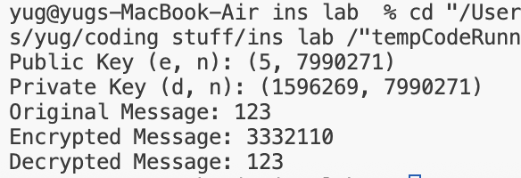

EXPERIMENT – 9

**Aim:** Write a program to generate SHA-1 hash

**Theory:**

**SHA-1 (Secure Hash Algorithm - 1)** is a **cryptographic hash function** that takes an input message and produces a **160-bit (20-byte) hash value**, commonly represented as a **40-digit hexadecimal number**.  
It is a **one-way function**, meaning the original data cannot be retrieved from the hash.

**Working Principle:**

1. **Input Processing:**  
   The message is divided into 512-bit blocks.
2. **Padding:**  
   A single ‘1’ bit is added, followed by ‘0’s, to make the message length congruent to 448 mod 512, then append the original length (64 bits).
3. **Initialization:**  
   SHA-1 uses **five 32-bit words** as initial hash values.
4. **Processing:**  
   Each block is processed in **80 rounds** using bitwise operations, rotations, and logical functions.
5. **Output:**  
   After all blocks are processed, the five hash values are concatenated to produce the **final 160-bit hash**.

### **Applications:**

* Digital signatures
* File integrity verification
* Password storage and verification
* Version control systems (e.g., Git uses SHA-1)

### **Advantages:**

* Produces a fixed-size output for any input.
* Simple and efficient to implement.

### **Limitations:**

* **Not collision-resistant** — can produce the same hash for different inputs.
* Replaced by more secure algorithms like **SHA-256** and **SHA-3**.

**Source code:**

#include <iostream>

#include <sstream>

#include <iomanip>

#include <vector>

#include <cstring>

#include <fstream>

#include <algorithm>

class SHA1 {

public:

SHA1() { reset(); }

void update(const std::string &s) {

update(reinterpret_cast<const unsigned char*>(s.c_str()), s.size());

}

std::string final() {

unsigned char digest[20];

finalize(digest);

std::ostringstream oss;

for (int i = 0; i < 20; ++i)

oss << std::hex << std::setw(2) << std::setfill('0') << (int)digest[i];

return oss.str();

}

void reset() {

h0 = 0x67452301;

h1 = 0xEFCDAB89;

h2 = 0x98BADCFE;

h3 = 0x10325476;

h4 = 0xC3D2E1F0;

buffer.clear();

bit_len = 0;

finalized = false;

}

private:

uint32_t h0, h1, h2, h3, h4;

std::vector<unsigned char> buffer;

uint64_t bit_len = 0;

bool finalized = false;

static uint32_t leftrotate(uint32_t value, uint32_t bits) {

return (value << bits) | (value >> (32 - bits));

}

void process_block(const unsigned char *block) {

uint32_t w[80];

for (int i = 0; i < 16; ++i) {

w[i] = (block[i * 4 + 0] << 24);

w[i] |= (block[i * 4 + 1] << 16);

w[i] |= (block[i * 4 + 2] << 8);

w[i] |= (block[i * 4 + 3]);

}

for (int i = 16; i < 80; ++i)

w[i] = leftrotate(w[i - 3] ^ w[i - 8] ^ w[i - 14] ^ w[i - 16], 1);

uint32_t a = h0, b = h1, c = h2, d = h3, e = h4;

for (int i = 0; i < 80; ++i) {

uint32_t f, k;

if (i < 20) { f = (b & c) | ((~b) & d); k = 0x5A827999; }

else if (i < 40) { f = b ^ c ^ d; k = 0x6ED9EBA1; }

else if (i < 60) { f = (b & c) | (b & d) | (c & d); k = 0x8F1BBCDC; }

else { f = b ^ c ^ d; k = 0xCA62C1D6; }

uint32_t temp = leftrotate(a, 5) + f + e + k + w[i];

e = d;

d = c;

c = leftrotate(b, 30);

b = a;

a = temp;

}

h0 += a;

h1 += b;

h2 += c;

h3 += d;

h4 += e;

}

void update(const unsigned char *data, size_t len) {

bit_len += len * 8;

for (size_t i = 0; i < len; ++i) {

buffer.push_back(data[i]);

if (buffer.size() == 64) {

process_block(buffer.data());

buffer.clear();

}

}

}

void finalize(unsigned char digest[20]) {

if (finalized) return;

finalized = true;

buffer.push_back(0x80);

while ((buffer.size() % 64) != 56)

buffer.push_back(0x00);

unsigned char length_bytes[8];

for (int i = 0; i < 8; ++i)

length_bytes[7 - i] = (bit_len >> (i * 8)) & 0xFF;

buffer.insert(buffer.end(), length_bytes, length_bytes + 8);

for (size_t i = 0; i < buffer.size(); i += 64)

process_block(&buffer[i]);

uint32_t h[5] = {h0, h1, h2, h3, h4};

for (int i = 0; i < 5; ++i) {

digest[i * 4 + 0] = (h[i] >> 24) & 0xFF;

digest[i * 4 + 1] = (h[i] >> 16) & 0xFF;

digest[i * 4 + 2] = (h[i] >> 8) & 0xFF;

digest[i * 4 + 3] = h[i] & 0xFF;

}

}

};

std::string hashString(const std::string& input) {

SHA1 sha;

sha.update(input);

return sha.final();

}

void toLowerCase(std::string& str) {

std::transform(str.begin(), str.end(), str.begin(), ::tolower);

}

bool verifyHash(const std::string& input, const std::string& target_hash) {

std::string computed = hashString(input);

std::string target = target_hash;

toLowerCase(computed);

toLowerCase(target);

return computed == target;

}

int main() {

while (true) {

std::cout << "\n=== SHA-1 Tool ===" << std::endl;

std::cout << "1. Hash a message" << std::endl;

std::cout << "2. Verify message matches hash" << std::endl;

std::cout << "3. Exit" << std::endl;

std::cout << "\nChoice: ";

int choice;

std::cin >> choice;

std::cin.ignore();

if (choice == 1) {

std::string input;

std::cout << "Enter text to hash: ";

std::getline(std::cin, input);

std::cout << "SHA-1 hash: " << hashString(input) << std::endl;

} else if (choice == 2) {

std::string input, hash;

std::cout << "Enter message: ";

std::getline(std::cin, input);

std::cout << "Enter hash: ";

std::getline(std::cin, hash);

if (verifyHash(input, hash)) {

std::cout << "✓ Match! The message produces this hash." << std::endl;

} else {

std::cout << "✗ No match. The message does not produce this hash." << std::endl;

}

} else if (choice == 3) {

std::cout << "Goodbye!" << std::endl;

break;

} else {

std::cout << "Invalid choice." << std::endl;

}

}

return 0;

}

**Output:**

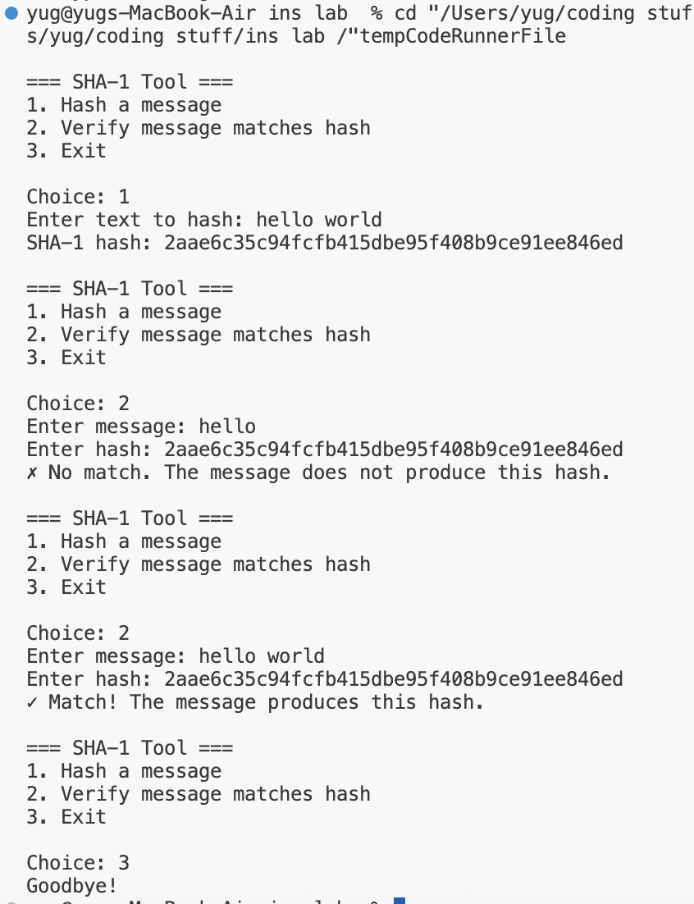

EXPERIMENT – 10

**Aim:** Write a program to implement a digital signature algorithm

**Theory:**

A **Digital Signature** is a **cryptographic technique** that ensures the **authenticity**, **integrity**, and **non-repudiation** of a message.  
It allows a sender to sign a message using a **private key**, and the receiver to verify it using the **public key**.

The **Digital Signature Algorithm (DSA)** is a **public key algorithm** based on **modular arithmetic** and **discrete logarithms**.

**Working Principle:**

**1. Key Generation:**

* Choose a **prime modulus p** and a **subprime q**, where q divides (p−1).
* Select a **generator g** of order q modulo p.
* Choose a random **private key x** (1 < x < q).
* Compute **public key y = gˣ mod p**.

**2. Signature Generation:**

* Select a random number **k** (1 < k < q).
* Compute **r = (gᵏ mod p) mod q**.
* Compute **s = (k⁻¹ × (H(m) + x × r)) mod q**,  
  where H(m) is the hash of the message.

The **signature** is the pair **(r, s)**.

**3. Signature Verification:**

* Compute **w = s⁻¹ mod q**.
* Compute **u₁ = (H(m) × w) mod q**, **u₂ = (r × w) mod q**.
* Compute **v = ((gᵘ¹ × yᵘ²) mod p) mod q**.
* If **v == r**, the signature is **valid**

**Applications**

* Email and document authentication
* Software distribution
* Secure financial transactions
* Digital certificates (used in SSL/TLS)

**Advantages:**

* Provides **data integrity** and **authentication**.
* Ensures **non-repudiation** (sender cannot deny sending).

**Limitations:**

* More computationally expensive than symmetric encryption.
* Requires careful random number generation for **k**, else security is compromised.

**Source code:**

#include <iostream>

#include <string>

#include <cmath>

#include <ctime>

#include <sstream>

#include <iomanip>

#include <vector>

// Simple big integer class for DSA operations (limited to 64-bit for simplicity)

class BigInt {

public:

long long value;

BigInt(long long v = 0) : value(v) {}

BigInt operator+(const BigInt& other) const {

return BigInt(value + other.value);

}

BigInt operator-(const BigInt& other) const {

return BigInt(value - other.value);

}

BigInt operator*(const BigInt& other) const {

return BigInt(value * other.value);

}

BigInt operator%(const BigInt& other) const {

return BigInt(value % other.value);

}

bool operator==(const BigInt& other) const {

return value == other.value;

}

bool operator<(const BigInt& other) const {

return value < other.value;

}

};

// Modular exponentiation: (base^exp) % mod

long long modPow(long long base, long long exp, long long mod) {

long long result = 1;

base = base % mod;

while (exp > 0) {

if (exp % 2 == 1) {

result = (result * base) % mod;

}

exp = exp >> 1;

base = (base * base) % mod;

}

return result;

}

// Extended Euclidean Algorithm for modular inverse

long long modInverse(long long a, long long m) {

long long m0 = m, x0 = 0, x1 = 1;

if (m == 1) return 0;

while (a > 1) {

long long q = a / m;

long long t = m;

m = a % m;

a = t;

t = x0;

x0 = x1 - q * x0;

x1 = t;

}

if (x1 < 0) x1 += m0;

return x1;

}

// Simple primality test (Miller-Rabin would be better for production)

bool isPrime(long long n) {

if (n <= 1) return false;

if (n <= 3) return true;

if (n % 2 == 0 || n % 3 == 0) return false;

for (long long i = 5; i * i <= n; i += 6) {

if (n % i == 0 || n % (i + 2) == 0)

return false;

}

return true;

}

// Simple hash function (in production, use SHA-256)

long long simpleHash(const std::string& message) {

long long hash = 0;

for (char c : message) {

hash = (hash * 31 + c) % 1000000007;

}

return hash;

}

class DSA {

private:

long long p; // Prime modulus

long long q; // Prime divisor of p-1

long long g; // Generator

long long x; // Private key

long long y; // Public key

// Generate a prime number

long long generatePrime(long long min, long long max) {

srand(time(0));

for (int attempts = 0; attempts < 1000; attempts++) {

long long candidate = min + rand() % (max - min);

if (isPrime(candidate)) {

return candidate;

}

}

return 0;

}

// Find a generator g

long long findGenerator() {

for (long long h = 2; h < p; h++) {

g = modPow(h, (p - 1) / q, p);

if (g > 1) {

return g;

}

}

return 2;

}

public:

DSA() : p(0), q(0), g(0), x(0), y(0) {}

// Generate DSA parameters and keys

void generateKeys() {

std::cout << "Generating DSA parameters and keys..." << std::endl;

// Generate prime q (smaller prime)

q = generatePrime(1000, 5000);

std::cout << "q (prime divisor): " << q << std::endl;

// Generate prime p such that q divides (p-1)

for (int i = 2; i < 100; i++) {

long long candidate = i * q + 1;

if (isPrime(candidate)) {

p = candidate;

break;

}

}

std::cout << "p (prime modulus): " << p << std::endl;

// Find generator g

g = findGenerator();

std::cout << "g (generator): " << g << std::endl;

// Generate private key x (random number < q)

srand(time(0) + 1);

x = (rand() % (q - 1)) + 1;

std::cout << "x (private key): " << x << std::endl;

// Calculate public key y = g^x mod p

y = modPow(g, x, p);

std::cout << "y (public key): " << y << std::endl;

std::cout << "\nKeys generated successfully!\n" << std::endl;

}

// Sign a message

std::pair<long long, long long> sign(const std::string& message) {

if (p == 0 || q == 0) {

std::cout << "Error: Keys not generated yet!" << std::endl;

return {0, 0};

}

// Hash the message

long long h = simpleHash(message);

std::cout << "Message hash: " << h << std::endl;

// Generate random k (1 < k < q)

srand(time(0) + rand());

long long k = (rand() % (q - 2)) + 2;

std::cout << "Random k: " << k << std::endl;

// Calculate r = (g^k mod p) mod q

long long r = modPow(g, k, p) % q;

// Calculate s = (k^-1 * (h + x*r)) mod q

long long k_inv = modInverse(k, q);

long long s = (k_inv * (h + x * r)) % q;

// Make sure r and s are not zero

if (r == 0 || s == 0) {

std::cout << "Error: Invalid signature (r or s is zero), regenerating..." << std::endl;

return sign(message);

}

std::cout << "\nSignature generated:" << std::endl;

std::cout << "r = " << r << std::endl;

std::cout << "s = " << s << std::endl;

return {r, s};

}

// Verify a signature

bool verify(const std::string& message, long long r, long long s) {

if (p == 0 || q == 0) {

std::cout << "Error: Keys not generated yet!" << std::endl;

return false;

}

// Check if r and s are in valid range

if (r <= 0 || r >= q || s <= 0 || s >= q) {

std::cout << "Invalid signature: r or s out of range" << std::endl;

return false;

}

// Hash the message

long long h = simpleHash(message);

std::cout << "Message hash: " << h << std::endl;

// Calculate w = s^-1 mod q

long long w = modInverse(s, q);

std::cout << "w = " << w << std::endl;

// Calculate u1 = (h * w) mod q

long long u1 = (h * w) % q;

std::cout << "u1 = " << u1 << std::endl;

// Calculate u2 = (r * w) mod q

long long u2 = (r * w) % q;

std::cout << "u2 = " << u2 << std::endl;

// Calculate v = ((g^u1 * y^u2) mod p) mod q

long long v1 = modPow(g, u1, p);

long long v2 = modPow(y, u2, p);

long long v = ((v1 * v2) % p) % q;

std::cout << "v = " << v << std::endl;

// Signature is valid if v == r

return v == r;

}

void displayPublicKey() {

std::cout << "\n=== Public Key ===" << std::endl;

std::cout << "p = " << p << std::endl;

std::cout << "q = " << q << std::endl;

std::cout << "g = " << g << std::endl;

std::cout << "y = " << y << std::endl;

}

};

int main() {

DSA dsa;

std::string message;

long long r = 0, s = 0;

while (true) {

std::cout << "\n=== Digital Signature Algorithm (DSA) ===" << std::endl;

std::cout << "1. Generate Keys" << std::endl;

std::cout << "2. Sign a Message" << std::endl;

std::cout << "3. Verify a Signature" << std::endl;

std::cout << "4. Display Public Key" << std::endl;

std::cout << "5. Exit" << std::endl;

std::cout << "\nChoice: ";

int choice;

std::cin >> choice;

std::cin.ignore();

if (choice == 1) {

dsa.generateKeys();

} else if (choice == 2) {

std::cout << "Enter message to sign: ";

std::getline(std::cin, message);

auto signature = dsa.sign(message);

r = signature.first;

s = signature.second;

} else if (choice == 3) {

std::cout << "Enter message to verify: ";

std::getline(std::cin, message);

std::cout << "Enter r: ";

std::cin >> r;

std::cout << "Enter s: ";

std::cin >> s;

std::cin.ignore();

std::cout << "\nVerifying signature..." << std::endl;

bool isValid = dsa.verify(message, r, s);

if (isValid) {

std::cout << "\n✓ SIGNATURE VALID! The message is authentic." << std::endl;

} else {

std::cout << "\n✗ SIGNATURE INVALID! The message may have been tampered with." << std::endl;

}

} else if (choice == 4) {

dsa.displayPublicKey();

} else if (choice == 5) {

std::cout << "Goodbye!" << std::endl;

break;

} else {

std::cout << "Invalid choice." << std::endl;

}

}

return 0;

}

**Output:**

